EWMA correlation: USDJPY and USDCAD
Method 06 / daily log returns / lambda = 0.94 / Alpari D1 full available history

Study setup
Logical pair: USDJPY , USDCAD
Broker symbols: USDJPY_i , USDCAD_i
Snapshot: 2026-11-03_majors_alpari_D1
Timeframe: D1
Matched return window: 1999-01-05 to 2026-11-02 (UTC bar dates)
Matched return count n: 7186
Dropped unfinished last bar dated 2026-11-03 UTC after a tick-volume check against the prior complete day.
Lambda: 0.94 (today weight 0.06)
Burn-in ignored in path summaries and chart: first 60 updates
Mean adjustment: each leg demeaned by its mean on the matched rows
Seeds: c_0 = v_x,0 = v_y,0 = 0
Complete matched rows (Excel): USDJPY-USDCAD_EWMA_D1.xlsx
Complete matched rows (HTML table): USDJPY-USDCAD_EWMA_D1_data.html

Method carried forward
EWMA correlation updates covariance and variances of mean-adjusted daily log returns of close, ln(close_t / close_t-1), with lambda = 0.94 (6% weight on today's product or square, 94% on yesterday's EWMA state). Quotes are not inverted. Each leg is demeaned by its mean on the matched rows; that mean uses the full sample, so the rho path is a full-sample description, not a live filter. Seeds start at zero. Path summaries and the chart ignore the first 60 updates so the zero seed has faded. The headline is rho on the last day. rho is symmetric under swap of the two symbols. A high |rho| does not prove cause, lead-lag, or a trading signal. Today's return sits inside today's rho, so the estimate can only inform a later decision. Same-sample Pearson r is a side check only.

Results
Latest EWMA rho: 0.454132
Post-burn-in path (n=7126): mean=0.121293, median=0.141043, min=-0.840340, max=0.790839, std=0.297012
Share of post-burn-in days with |rho| >= 0.4: 24.42%; |rho| >= 0.7: 0.94%
Same-sample Pearson r: 0.027603
Latest rho minus r: 0.426529

Conclusion
Over 7186 matched daily log-return rows for USDJPY and USDCAD (broker quote directions unchanged), latest EWMA rho with lambda=0.94 is 0.4541 (positive, moderate recent linear link in this sample). After a 60-day burn-in, path mean is 0.1213, std is 0.2970, and the range is [-0.8403, 0.7908]. Same-sample Pearson r is 0.0276 (latest rho minus r = 0.4265). This does not establish cause, lead-lag, or a lasting trading rule.

Charts
Daily closes

Daily log returns
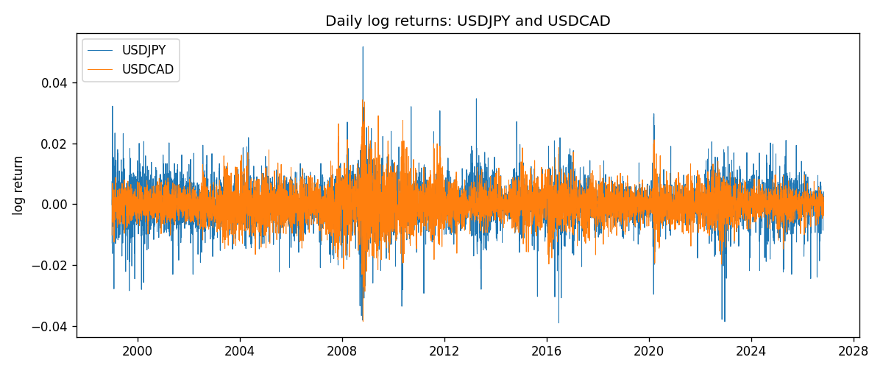
EWMA rho path with Pearson r reference
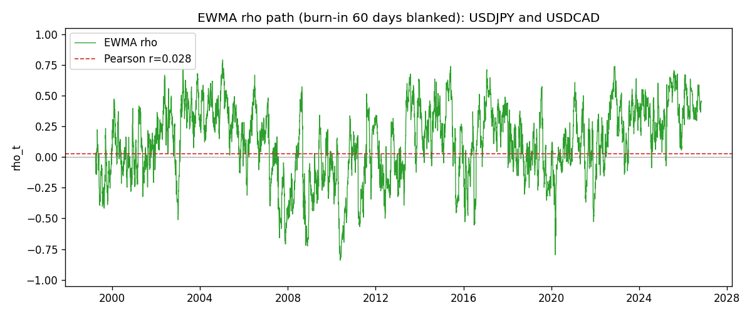

Data report
Every matched row that entered the EWMA recursion is stored in the sibling Excel workbook named USDJPY-USDCAD_EWMA_D1.xlsx. That file is the complete data archive for redrawing charts. Embedding all rows as a Word table is impractical at this length; the Word file holds the column list, column summaries, and the first and last 15 matched rows.
Columns: time, USDJPY_open, USDCAD_open, USDJPY_high, USDCAD_high, USDJPY_low, USDCAD_low, USDJPY_close, USDCAD_close, USDJPY_tick_volume, USDCAD_tick_volume, USDJPY_spread, USDCAD_spread, USDJPY_real_volume, USDCAD_real_volume, USDJPY_log_return, USDCAD_log_return, USDJPY_x_demeaned, USDCAD_y_demeaned, c_t, v_x, v_y, rho_t
Column summaries (matched calculation rows)
column | count | mean | std | min | 25% | 50% | 75% | max
USDJPY_open | 7186 | 113.80748 | 19.222412 | 75.693 | 104.39025 | 110.981 | 120.70625 | 163.824
USDCAD_open | 7186 | 1.266789 | 0.16892251 | 0.9168 | 1.118445 | 1.2985 | 1.37213 | 1.6183
USDJPY_high | 7186 | 114.30511 | 19.284087 | 76.001 | 104.8685 | 111.4395 | 121.2675 | 163.978
USDCAD_high | 7186 | 1.2716872 | 0.16888037 | 0.9336 | 1.122975 | 1.303895 | 1.37655 | 1.619
USDJPY_low | 7186 | 113.28446 | 19.150257 | 75.402 | 103.88 | 110.53 | 120.1715 | 163.628
USDCAD_low | 7186 | 1.2622311 | 0.16895752 | 0.9056 | 1.114125 | 1.293555 | 1.367815 | 1.6102
USDJPY_close | 7186 | 113.82065 | 19.237762 | 75.811 | 104.38275 | 111.018 | 120.69375 | 163.851
USDCAD_close | 7186 | 1.2668036 | 0.16889539 | 0.916 | 1.118165 | 1.29848 | 1.372395 | 1.6137
USDJPY_tick_volume | 7186 | 106329.64 | 179429.89 | 149 | 9948.5 | 53187 | 92874.5 | 1803508
USDCAD_tick_volume | 7186 | 81037.769 | 147318.12 | 37 | 5546.5 | 40944 | 71631 | 1410818
USDJPY_spread | 7186 | 20.270804 | 17.617829 | 0 | 6 | 11 | 30 | 50
USDCAD_spread | 7186 | 23.436682 | 18.263202 | 0 | 9 | 17 | 40 | 60
USDJPY_real_volume | 7186 | 3.4776211e+10 | 1.6092546e+11 | 0 | 0 | 0 | 0 | 3.8834203e+12
USDCAD_real_volume | 7186 | 1.8381818e+10 | 9.6701063e+10 | 0 | 0 | 0 | 0 | 2.5751613e+12
USDJPY_log_return | 7186 | 5.053e-05 | 0.00620694 | -0.03908203 | -0.00319936 | 0.00011986 | 0.0034094 | 0.05184024
USDCAD_log_return | 7186 | -1.555e-05 | 0.00514357 | -0.03859748 | -0.00283709 | 4.741e-05 | 0.00272359 | 0.03436319
USDJPY_x_demeaned | 7186 | -0 | 0.00620694 | -0.03913256 | -0.00324989 | 6.933e-05 | 0.00335888 | 0.05178971
USDCAD_y_demeaned | 7186 | 0 | 0.00514357 | -0.03858193 | -0.00282154 | 6.296e-05 | 0.00273914 | 0.03437873
c_t | 7186 | 8.7e-07 | 1.876e-05 | -0.00024425 | -1.48e-06 | 2.64e-06 | 7.42e-06 | 6.398e-05
v_x | 7186 | 3.849e-05 | 3.191e-05 | 0 | 1.904e-05 | 3.095e-05 | 4.776e-05 | 0.0004123
v_y | 7186 | 2.644e-05 | 3.124e-05 | 3.69e-06 | 1.172e-05 | 1.802e-05 | 2.896e-05 | 0.00040857
rho_t | 7186 | 0.12091377 | 0.29657596 | -0.84034048 | -0.0779877 | 0.13934971 | 0.34937323 | 1
First 15 matched rows (selected columns)
time | USDJPY_close | USDCAD_close | USDJPY_log_return | USDCAD_log_return | USDJPY_x_demeaned | USDCAD_y_demeaned | c_t | v_x | v_y | rho_t
1999-01-05 | 111.92 | 1.5123 | -0.00017868311 | -0.010131666 | -0.0002292113 | -0.010116117 | 1.391237e-07 | 3.1522692e-09 | 6.1401497e-06 | 1
1999-01-06 | 112.77 | 1.5118 | 0.0075660159 | -0.0003306769 | 0.0075154877 | -0.00031512856 | -1.1324409e-08 | 3.3919164e-06 | 5.7776991e-06 | -0.0025580882
1999-01-07 | 111.33 | 1.5141 | -0.012851583 | 0.0015202092 | -0.012902111 | 0.0015357575 | -1.1995157e-06 | 1.3176269e-05 | 5.5725502e-06 | -0.13998539
1999-01-08 | 110.8 | 1.511 | -0.0047719894 | -0.0020495197 | -0.0048225176 | -0.0020339714 | -5.3901301e-07 | 1.3781094e-05 | 5.4864196e-06 | -0.061988753
1999-01-11 | 109.02 | 1.5057 | -0.016195423 | -0.0035137769 | -0.016245951 | -0.0034982286 | 2.9032508e-06 | 2.8790083e-05 | 5.8914906e-06 | 0.22292075
1999-01-12 | 112.6 | 1.5157 | 0.032310364 | 0.0066194721 | 0.032259836 | 0.0066350204 | 1.5571736e-05 | 8.9504499e-05 | 8.179411e-06 | 0.57551094
1999-01-13 | 113.52 | 1.5226 | 0.0081373171 | 0.0045420214 | 0.008086789 | 0.0045575698 | 1.6848798e-05 | 8.8057998e-05 | 8.9349328e-06 | 0.60067406
1999-01-14 | 113.52 | 1.5332 | 0 | 0.0069376546 | -5.0528193e-05 | 0.006953203 | 1.581679e-05 | 8.2774671e-05 | 1.1299659e-05 | 0.51717433
1999-01-15 | 114.15 | 1.5245 | 0.0055343401 | -0.0056905671 | 0.0054838119 | -0.0056750187 | 1.3000539e-05 | 7.9612523e-05 | 1.2554029e-05 | 0.4112246
1999-01-18 | 114.16 | 1.526 | 8.7600193e-05 | 0.00098344542 | 3.7072e-05 | 0.00099899375 | 1.2222728e-05 | 7.4835854e-05 | 1.1860667e-05 | 0.4102596
1999-01-19 | 113.52 | 1.5302 | -0.0056219403 | 0.002748513 | -0.0056724685 | 0.0027640613 | 1.0548622e-05 | 7.2276317e-05 | 1.1607429e-05 | 0.36419141
1999-01-20 | 112.91 | 1.5211 | -0.0053879917 | -0.0059646885 | -0.0054385199 | -0.0059491401 | 1.1856975e-05 | 6.9714387e-05 | 1.3034519e-05 | 0.39333736
1999-01-21 | 113.87 | 1.5146 | 0.0084664056 | -0.0042823796 | 0.0084158774 | -0.0042668313 | 8.9910091e-06 | 6.9781144e-05 | 1.3344799e-05 | 0.29463435
1999-01-22 | 114.56 | 1.5184 | 0.0060412564 | 0.0025057712 | 0.0059907282 | 0.0025213195 | 9.357821e-06 | 6.7747605e-05 | 1.2925534e-05 | 0.31623032
1999-01-25 | 113.72 | 1.5197 | -0.0073594164 | 0.00085579808 | -0.0074099446 | 0.00087134642 | 8.408954e-06 | 6.6977185e-05 | 1.2195557e-05 | 0.29422374
Last 15 matched rows (selected columns)
time | USDJPY_close | USDCAD_close | USDJPY_log_return | USDCAD_log_return | USDJPY_x_demeaned | USDCAD_y_demeaned | c_t | v_x | v_y | rho_t
2026-10-13 | 158.305 | 1.4214 | -0.0018932826 | -0.0046395653 | -0.0019438108 | -0.0046240169 | 5.0265994e-06 | 1.9769274e-05 | 7.2198348e-06 | 0.42074144
2026-10-14 | 158.317 | 1.42356 | 7.5800166e-05 | 0.0015184751 | 2.5271972e-05 | 0.0015340234 | 4.7273295e-06 | 1.8583156e-05 | 6.9278384e-06 | 0.41663646
2026-10-15 | 158.024 | 1.41843 | -0.0018524319 | -0.0036101503 | -0.0019029601 | -0.003594602 | 4.8541128e-06 | 1.7685442e-05 | 7.2874379e-06 | 0.42757714
2026-10-16 | 157.964 | 1.41357 | -0.00037976126 | -0.0034322068 | -0.00043028945 | -0.0034166584 | 4.6510752e-06 | 1.6635424e-05 | 7.5506049e-06 | 0.41499756
2026-10-19 | 158.517 | 1.41091 | 0.0034946841 | -0.0018835331 | 0.0034441559 | -0.0018679848 | 3.9859928e-06 | 1.6349031e-05 | 7.3069306e-06 | 0.36468929
2026-10-20 | 158.16 | 1.40569 | -0.0022546642 | -0.0037066008 | -0.0023051924 | -0.0036910525 | 4.2573484e-06 | 1.5686924e-05 | 7.6859469e-06 | 0.38772304
2026-10-21 | 158.108 | 1.4045 | -0.00032883504 | -0.00084691787 | -0.00037936323 | -0.00083136954 | 4.020831e-06 | 1.4754344e-05 | 7.2662606e-06 | 0.3883295
2026-10-22 | 156.755 | 1.40081 | -0.0085942669 | -0.0026307268 | -0.0086447951 | -0.0026151785 | 5.136042e-06 | 1.8353032e-05 | 7.2406345e-06 | 0.44553964
2026-10-23 | 156.81 | 1.40085 | 0.00035080446 | 2.85545e-05 | 0.00030027627 | 4.4102836e-05 | 4.8286741e-06 | 1.725726e-05 | 6.8063131e-06 | 0.44553929
2026-10-26 | 157.458 | 1.40093 | 0.0041238746 | 5.7106554e-05 | 0.0040733465 | 7.265489e-05 | 4.5567106e-06 | 1.7217354e-05 | 6.3982511e-06 | 0.4341478
2026-10-27 | 157.894 | 1.40449 | 0.0027651658 | 0.0025379458 | 0.0027146376 | 0.0025534941 | 4.6992166e-06 | 1.6626468e-05 | 6.4055759e-06 | 0.45535108
2026-10-28 | 157.743 | 1.39911 | -0.00095679538 | -0.0038379274 | -0.0010073236 | -0.003822379 | 4.648286e-06 | 1.5689762e-05 | 6.8978763e-06 | 0.4468142
2026-10-29 | 157.683 | 1.39895 | -0.00038043789 | -0.00011436495 | -0.00043096608 | -9.8816616e-05 | 4.371944e-06 | 1.475952e-05 | 6.4845896e-06 | 0.44688649
2026-10-30 | 157.516 | 1.39751 | -0.0010596481 | -0.0010298736 | -0.0011101763 | -0.0010143252 | 4.1771921e-06 | 1.3947898e-05 | 6.1572455e-06 | 0.45075114
2026-11-02 | 157.933 | 1.39837 | 0.0026438521 | 0.00061519094 | 0.0025933239 | 0.00063073928 | 4.0247033e-06 | 1.3514544e-05 | 5.8116807e-06 | 0.4541322

